PRACTICAL NO -10

Practical Title: Automation and Regression Testing

Module Name

Software Testing

Aim

To perform automation and regression testing on a sample Instagram Clone Login Module and verify its functionality under different test conditions.

Software Requirements

1. Operating System: Windows
2. Browser: Google Chrome
3. Application: Sample Instagram Clone Login Module
4. Testing Type: Automation Testing and Regression Testing

Introduction

Automation testing is a software testing technique in which test cases are executed using automation tools or scripts. Regression testing ensures that existing functionalities continue to work correctly after changes are made to the application.

In this practical, different test scenarios are used to verify the login functionality, input validation, user interface, and basic system behavior of a sample Instagram Clone Login Module.

Test Case Report

Scenario TC01

Scenario ID: TC01
Scenario: Verify login with valid credentials.

Test Steps:

1. Open the Instagram Clone Login Module.
2. Enter a valid username.
3. Enter a valid password.
4. Click on the Login button.

Test Input: Valid username and valid password.

Expected Result: The user should log in successfully.

Actual Result: To be filled after executing the test case.

Status: To be filled after execution.

Comments: Verify successful login functionality.

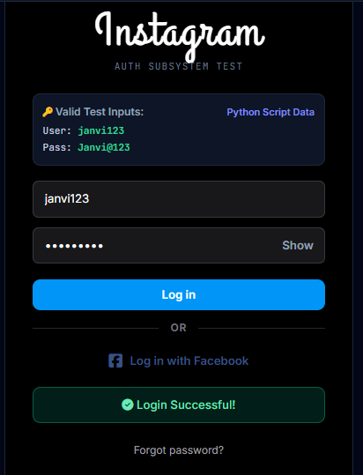
Scenario TC02

Scenario ID: TC02
Scenario: Verify login with an invalid username.

Test Steps:

1. Open the login page.
2. Enter an invalid username.
3. Enter a valid password.
4. Click on the Login button.

Test Input: Invalid username and valid password.

Expected Result: The application should display an appropriate error message.

Actual Result: To be filled after executing the test case.

Status: To be filled after execution.

Comments: Verify username validation.

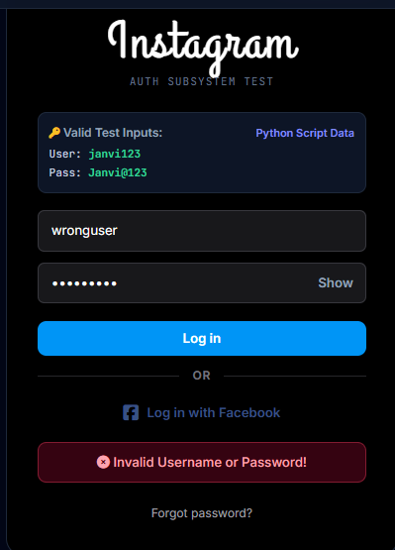
Scenario TC03

Scenario ID: TC03
Scenario: Verify login with an invalid password.

Test Steps:

1. Open the login page.
2. Enter a valid username.
3. Enter an invalid password.
4. Click on the Login button.

Test Input: Valid username and invalid password.

Expected Result: Login should be rejected and an appropriate error message should be displayed.

Actual Result: To be filled after executing the test case.

Status: To be filled after execution.

Comments: Verify password validation.
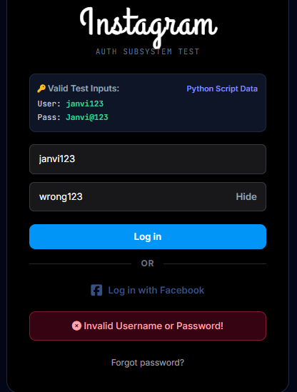

Scenario TC04

Scenario ID: TC04
Scenario: Verify login with both invalid username and password.

Test Steps:

1. Open the login page.
2. Enter an invalid username.
3. Enter an invalid password.
4. Click on the Login button.

Test Input: Invalid username and invalid password.

Expected Result: The application should reject the login attempt and display an appropriate error message.

Actual Result: To be filled after executing the test case.

Status: To be filled after execution.

Comments: Verify handling of invalid credentials.
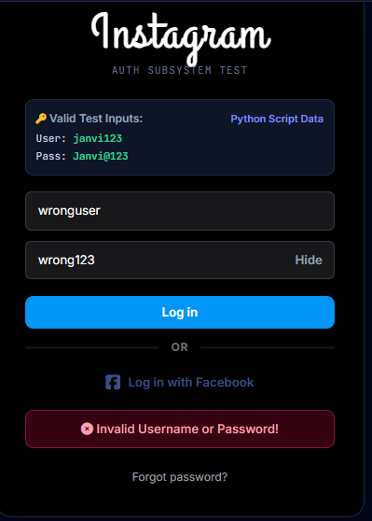
Scenario TC05

Scenario ID: TC05
Scenario: Verify login with an empty username field.

Test Steps:

1. Open the login page.
2. Leave the username field empty.
3. Enter a password.
4. Click on the Login button.

Test Input: Empty username and a password.

Expected Result: The application should ask the user to enter a username.

Actual Result: To be filled after executing the test case.

Status: To be filled after execution.

Comments: Verify username required-field validation.

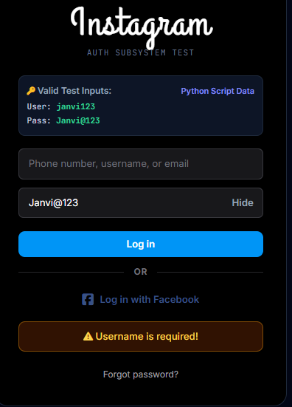
Scenario TC06

Scenario ID: TC06
Scenario: Verify login with an empty password field.

Test Steps:

1. Open the login page.
2. Enter a username.
3. Leave the password field empty.
4. Click on the Login button.

Test Input: Username and empty password.

Expected Result: The application should ask the user to enter a password.

Actual Result: To be filled after executing the test case.

Status: To be filled after execution.

Comments: Verify password required-field validation.

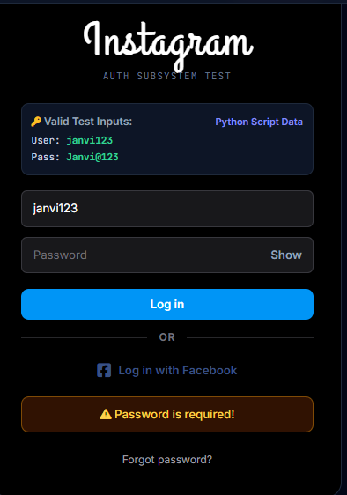
Scenario TC07

Scenario ID: TC07
Scenario: Verify login with both fields empty.

Test Steps:

1. Open the login page.
2. Leave both username and password fields empty.
3. Click on the Login button.

Test Input: Empty username and empty password.

Expected Result: The application should display appropriate validation messages.

Actual Result: To be filled after executing the test case.

Status: To be filled after execution.

Comments: Verify validation of empty fields.

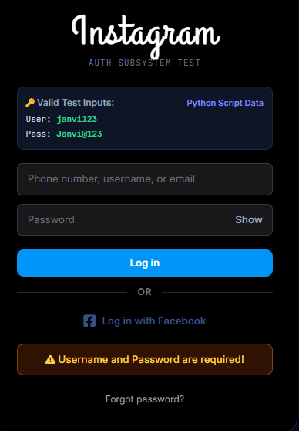

Scenario TC08

Scenario ID: TC08
Scenario: Verify password masking.

Test Steps:

1. Open the login page.
2. Enter a password in the password field.
3. Observe how the password is displayed.

Test Input: A sample password.

Expected Result: The password should be masked and should not be visible as plain text.

Actual Result: To be filled after executing the test case.

Status: To be filled after execution.

Comments: Verify password field security.

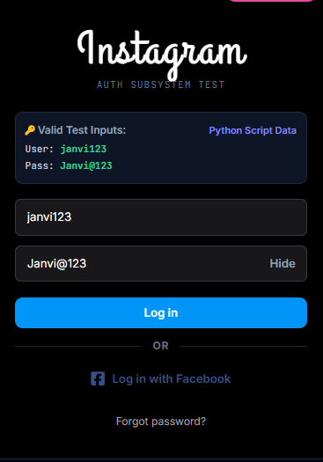
Scenario TC09

Scenario ID: TC09
Scenario: Verify the Login button functionality.

Test Steps:

1. Open the login page.
2. Enter the required login details.
3. Click on the Login button.
4. Observe the application response.

Test Input: Login credentials.

Expected Result: The Login button should respond correctly and initiate the login process.

Actual Result: To be filled after executing the test case.

Status: To be filled after execution.

Comments: Verify Login button functionality.

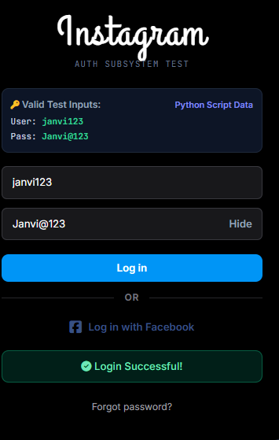
Scenario TC10

Scenario ID: TC10
Scenario: Verify username field input handling.

Test Steps:

1. Open the login page.
2. Enter a username in the username field.
3. Observe the entered value.
4. Submit the form.

Test Input: A sample username.

Expected Result: The username field should accept input according to the application's validation rules.

Actual Result: To be filled after executing the test case.

Status: To be filled after execution.

Comments: Verify username input handling.

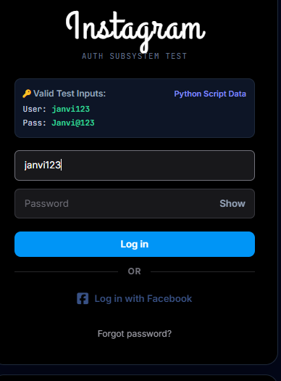
Scenario TC11

Scenario ID: TC11
Scenario: Verify password field input handling.

Test Steps:

1. Open the login page.
2. Enter a password.
3. Observe the password field.
4. Submit the form.

Test Input: A sample password.

Expected Result: The password field should accept input according to the application's validation rules.

Actual Result: To be filled after executing the test case.

Status: To be filled after execution.

Comments: Verify password input handling.

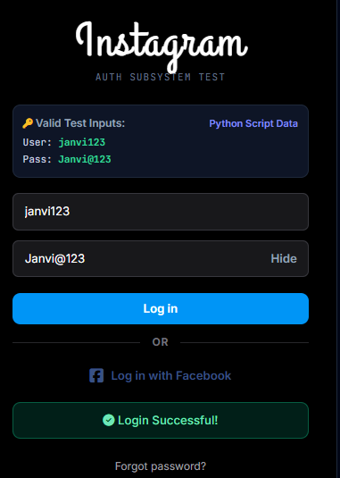
Scenario TC12

Scenario ID: TC12
Scenario: Verify the Forgot Password link.

Test Steps:

1. Open the login page.
2. Locate the Forgot Password link.
3. Click on the link.
4. Observe the resulting page or message.

Test Input: Click on Forgot Password.

Expected Result: The application should open the password recovery page or display the appropriate response.

Actual Result: To be filled after executing the test case.

Status: To be filled after execution.

Comments: Verify password recovery navigation.
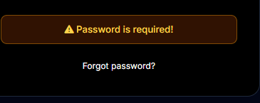

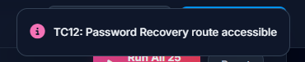
Scenario TC13

Scenario ID: TC13
Scenario: Verify the Sign Up link.

Test Steps:

1. Open the login page.
2. Locate the Sign Up link.
3. Click on the link.
4. Observe the resulting page.

Test Input: Click on Sign Up.

Expected Result: The application should navigate to the registration page or display the appropriate response.

Actual Result: To be filled after executing the test case.

Status: To be filled after execution.

Comments: Verify registration navigation.
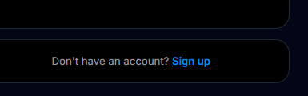



Scenario TC14

Scenario ID: TC14
Scenario: Verify the login page user interface.

Test Steps:

1. Open the login page.
2. Observe the page layout.
3. Check the username field, password field, buttons, and links.
4. Verify that the elements are displayed correctly.

Test Input: Open the login page.

Expected Result: All user interface elements should be displayed properly without unwanted overlap.

Actual Result: To be filled after executing the test case.

Status: To be filled after execution.

Comments: Verify login page UI.

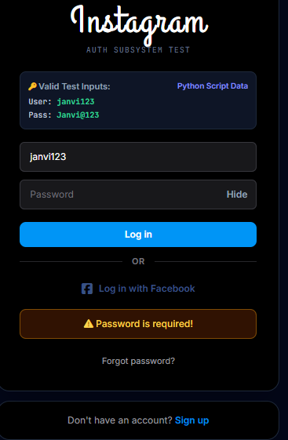
Scenario TC15

Scenario ID: TC15
Scenario: Verify login page layout on different screen sizes.

Test Steps:

1. Open the login page.
2. Resize the browser window or use responsive device mode.
3. Observe the page layout.
4. Check the visibility of the login fields and buttons.

Test Input: Different browser window sizes.

Expected Result: The login page should remain usable and its important elements should be visible.

Actual Result: To be filled after executing the test case.

Status: To be filled after execution.

Comments: Verify responsive layout.

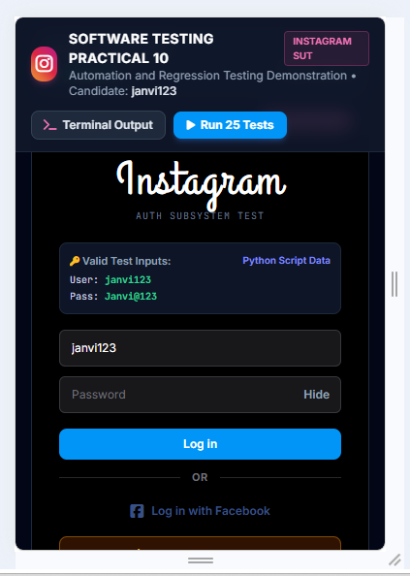
Scenario TC16

Scenario ID: TC16
Scenario: Verify login functionality after a page refresh.

Test Steps:

1. Open the login page.
2. Refresh the browser page.
3. Wait for the page to reload.
4. Check the login form.

Test Input: Browser refresh action.

Expected Result: The login page should reload correctly and the login form should remain available.

Actual Result: To be filled after executing the test case.

Status: To be filled after execution.

Comments: Verify page refresh behavior.

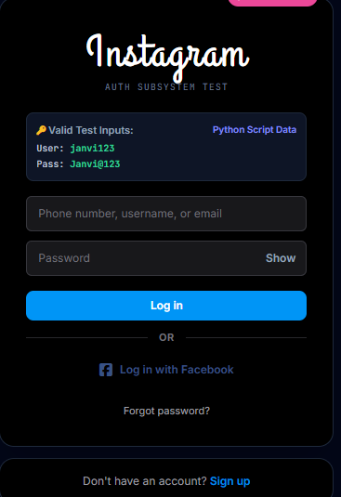
Scenario TC17

Scenario ID: TC17
Scenario: Verify that the login page loads correctly.

Test Steps:

1. Open the application URL.
2. Wait for the login page to load.
3. Observe the page elements.
4. Verify that the form is ready for use.

Test Input: Application URL.

Expected Result: The login page should load without errors and display the required elements.

Actual Result: To be filled after executing the test case.

Status: To be filled after execution.

Comments: Verify initial page loading.

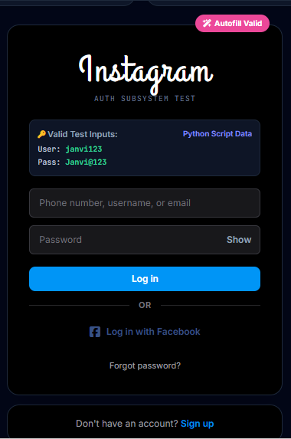
Scenario TC18

Scenario ID: TC18
Scenario: Verify repeated login attempts.

Test Steps:

1. Open the login page.
2. Enter invalid login credentials.
3. Click the Login button.
4. Repeat the attempt.
5. Observe the application response.

Test Input: Repeated attempts using invalid credentials.

Expected Result: The application should handle repeated attempts according to its validation and security rules.

Actual Result: To be filled after executing the test case.

Status: To be filled after execution.

Comments: Verify repeated login attempt handling.

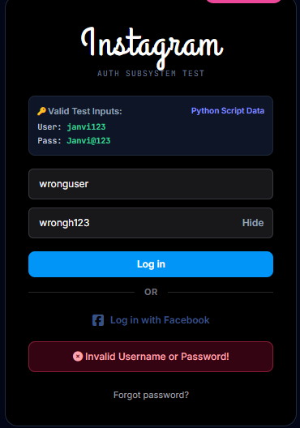
Scenario TC19

Scenario ID: TC19
Scenario: Verify that error messages are displayed correctly.

Test Steps:

1. Open the login page.
2. Enter invalid credentials.
3. Click the Login button.
4. Observe the displayed error message.

Test Input: Invalid login credentials.

Expected Result: A clear and appropriate error message should be displayed.

Actual Result: To be filled after executing the test case.

Status: To be filled after execution.

Comments: Verify error message handling.

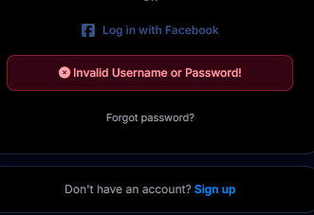
Scenario TC20

Scenario ID: TC20
Scenario: Verify navigation after successful login.

Test Steps:

1. Open the login page.
2. Enter valid credentials for the test application.
3. Click the Login button.
4. Observe the next page.

Test Input: Valid login credentials.

Expected Result: The application should navigate to the expected page after successful authentication.

Actual Result: To be filled after executing the test case.

Status: To be filled after execution.

Comments: Verify post-login navigation.

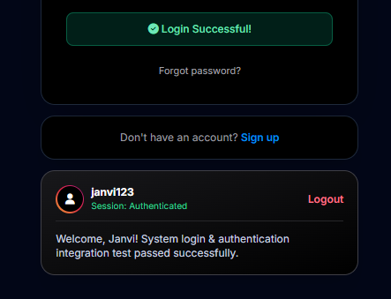

Scenario TC21

Scenario ID: TC21
Scenario: Perform regression testing on the login functionality.

Test Steps:

1. Open the login page after an application change.
2. Enter valid credentials.
3. Click the Login button.
4. Verify that login still works as expected.

Test Input: Valid login credentials.

Expected Result: Existing login functionality should continue to work after the application change.

Actual Result: To be filled after executing the test case.

Status: To be filled after execution.

Comments: Verify that changes have not affected existing login functionality.

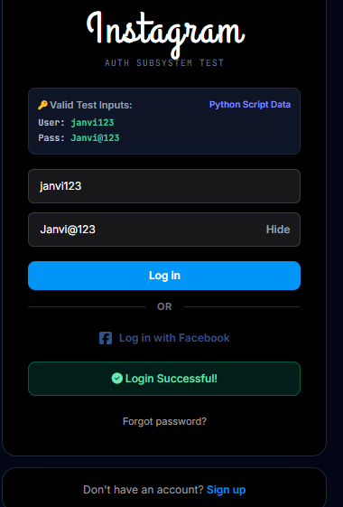


Scenario TC22

Scenario ID: TC22
Scenario: Perform regression testing on field validation.

Test Steps:

1. Open the login page.
2. Leave the username field empty and submit the form.
3. Repeat with the password field empty.
4. Observe the validation messages.

Test Input: Missing username or password.

Expected Result: Required-field validation should continue to work correctly after application changes.

Actual Result: To be filled after executing the test case.

Status: To be filled after execution.

Comments: Verify regression of input validation.

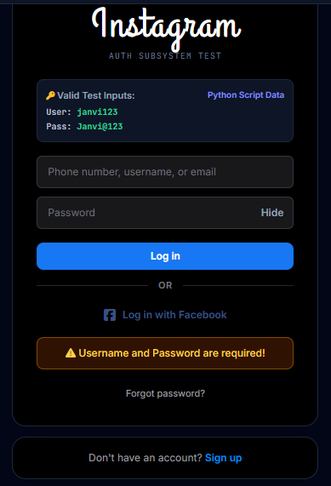
Scenario TC23

Scenario ID: TC23
Scenario: Verify integration of the login form with authentication.

Test Steps:

1. Open the login page.
2. Enter the test credentials.
3. Click the Login button.
4. Observe the response from the authentication component.

Test Input: Valid or invalid test credentials.

Expected Result: The login form should communicate with the authentication component and handle its response correctly.

Actual Result: To be filled after executing the test case.

Status: To be filled after execution.

Comments: Verify login and authentication integration. This test requires an application with authentication functionality.

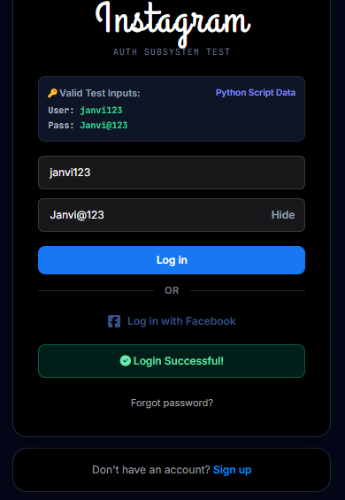

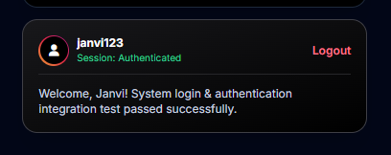
Scenario TC24

Scenario ID: TC24
Scenario: Verify system behavior during login.

Test Steps:

1. Open the application.
2. Enter test credentials.
3. Submit the login form.
4. Observe the overall system response.

Test Input: Test login credentials.

Expected Result: The application should process the login request and display an appropriate response without unexpected errors.

Actual Result: To be filled after executing the test case.

Status: To be filled after execution.

Comments: Verify overall login system behavior.

Scenario TC25

Scenario ID: TC25
Scenario: Verify the overall login module after regression testing.

Test Steps:

1. Open the login page.
2. Verify that the username and password fields are visible.
3. Test the required-field validation.
4. Test the Login button.
5. Verify error handling and navigation.
6. Confirm that the previously tested functions still work.

Test Input: Valid credentials, invalid credentials, and empty fields.

Expected Result: The login module should function according to its requirements, and existing functionality should remain unaffected by changes.

Actual Result: To be filled after executing the test case.

Status: To be filled after execution.

Comments: Perform a final regression check of the login module.

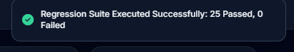

Result

Automation and regression testing scenarios for the sample Instagram Clone Login Module were prepared. Each test case should be executed against the application, and its actual result and status should be recorded based on the observed output.

Conclusion

This practical helps in understanding automation testing, regression testing, input validation, error handling, and verification of existing application functionality.

